HTML 5 – ASSIGNMENT

1. What are the new tags added in HTML5?

Ans. Header, Footer, Section, Article, NAV, Mark, Main, Dialog etc.

Example:

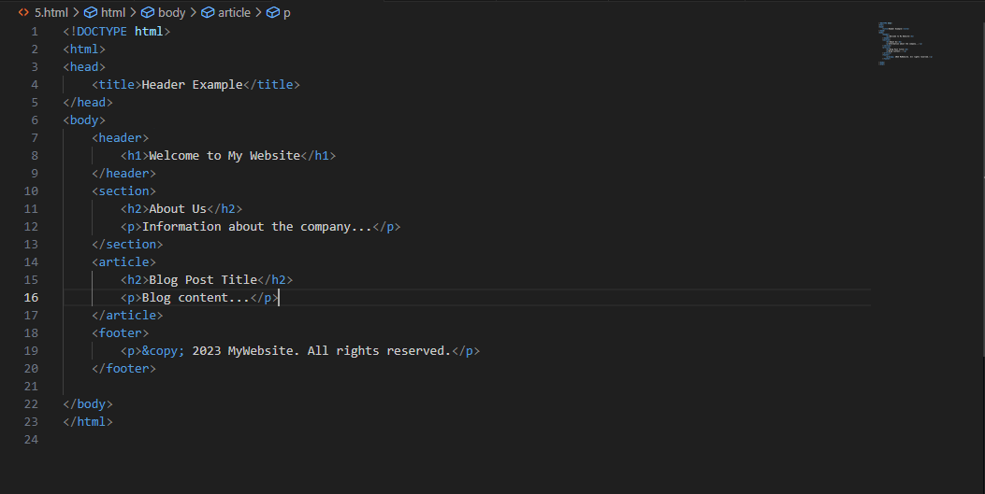

Output:



2. How to embed audio and video in a webpage?

Ans. The HTML <video> element is used to show a video in webpage.

The HTML <audio> element is used to show an audio in webpage.

Example:

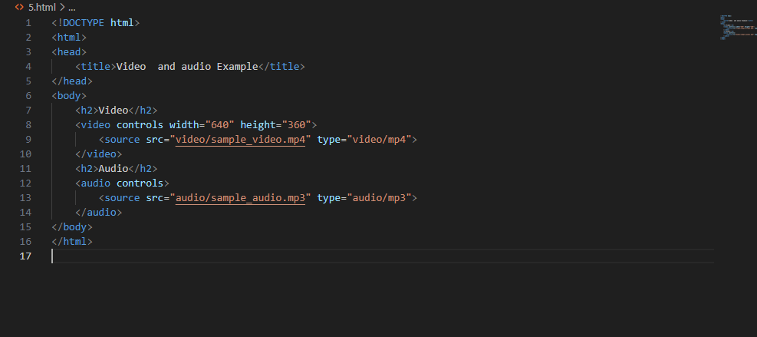

3. Semantic element in HTML5?

Ans. A semantic element clearly describe its meaning.

Example:

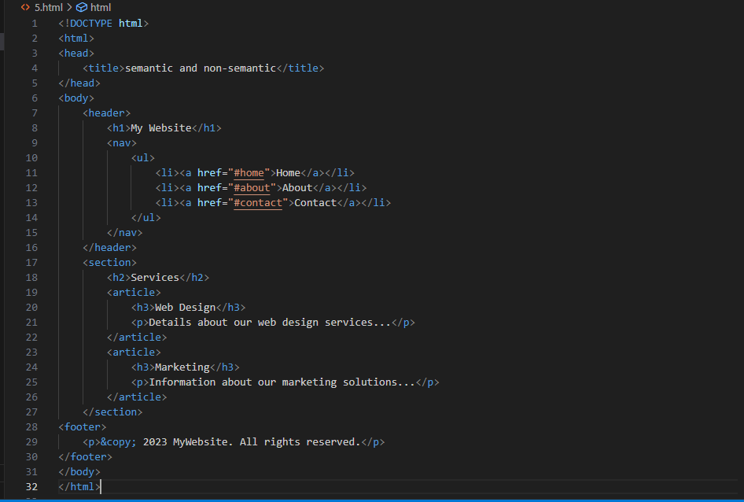

4. canvas and svg tags

Ans. Canvas

The Html <canvas> elements is used to draw graphics on web page. The <canvas> elements is only a container for graphics. You must use javascript to actually draw the graphics.

Example:

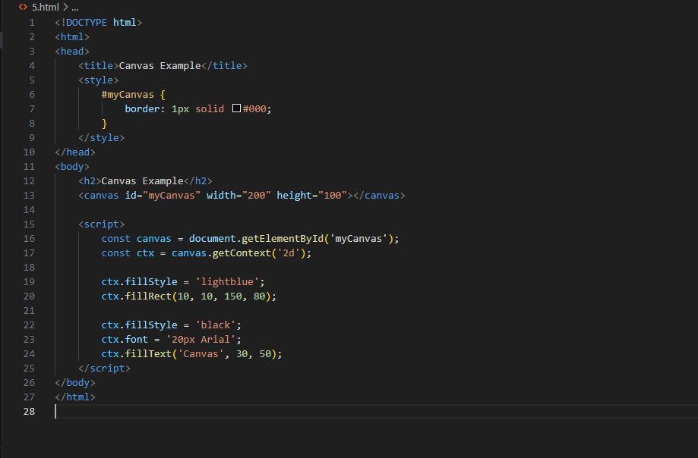

SVG

The html <svg> elements is a container for svg graphics..

Example:

